Source A

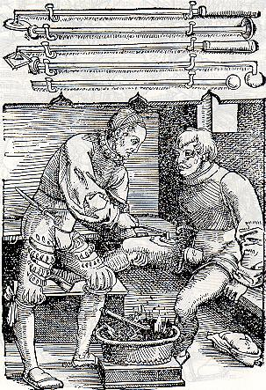
An engraving showing the work of Ambroise Paré. In the 1530’s he developed a new technique for gun shot wounds using an old Roman medicine. It was one of many key discoveries he made.

Source B

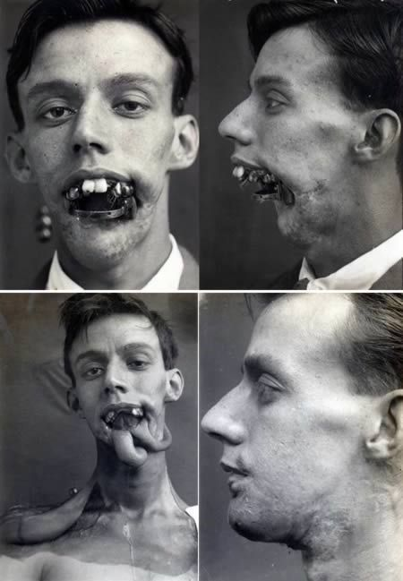
Series of photographs depicting the recovery of a patient following a serious facial injury in WWI. The treatment is a tubed pedicle developed by Dr Harold Gillies.

Source

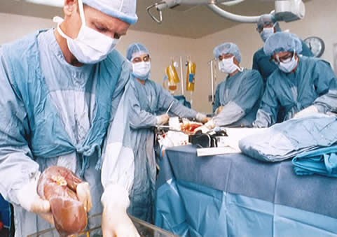
A modern operation takes place. In this case the patient is having a liver transplant. Transplant surgery was first developed in the 1960’s; the first successful operation was a heart transplant performed by Dr Christiaan Barnard in 1967.

